UNIVERSITY OF MINDANAO
College of Engineering Education — Surveying Laboratory
Digital Terrain Model (DTM) Simulator
User Manual
Developed by Engr. JF Item
Laboratory Custodian, Surveying Laboratory

1. Purpose
The Digital Terrain Model (DTM) Simulator is an interactive teaching and demonstration tool for the Surveying Laboratory. It reproduces, in software, the same workflow a field survey team follows when turning raw measurements into an engineering decision:
Field Survey Data → Coordinate Processing → Terrain Surface Generation → Contour Mapping → Engineering Interpretation
The simulator lets students and visitors explore this pipeline hands-on: load survey points, watch a terrain surface and contour map generate in real time, and see how that surface translates into engineering judgments — slope classification, drainage direction, and earthwork volume for a proposed road.
It is intended for classroom demonstration and self-directed learning. It is not a certified survey or engineering design tool, and its calculations should not be used for actual construction without verification by a licensed engineer or geodetic engineer.

2. Theory

2.1 Triangulated Irregular Networks (TIN)
A TIN turns a scattered set of survey points into a continuous surface by connecting them into non-overlapping triangles. The simulator builds this using Delaunay triangulation, a method that maximizes the minimum angle of every triangle — avoiding long, thin slivers that would distort the surface. Each triangle is assumed to be a flat plane, so the more points that are collected (and the better they capture breaklines like ridges and valleys), the more accurately the TIN represents the real ground.

2.2 Contour Mapping
A contour line traces every point on the surface at the same elevation. The simulator interpolates the TIN onto a regular grid, then draws lines at a chosen interval (0.5, 1.0, 2.0, or 5.0 m). Closely spaced contours indicate steep terrain; widely spaced contours indicate gentle terrain. This is the standard way engineers read a three-dimensional landscape on a flat drawing.

2.3 Slope Classification (Philippine BSWM Standard)
Average slope is computed by fitting a plane to each TIN triangle, deriving its steepness from the plane's normal vector, and averaging across all triangles (weighted by area). The result is classified using the Bureau of Soils and Water Management (BSWM) slope grouping, the standard used nationwide in Philippine land and geohazard evaluation:
Group | Slope Range | Description
A | 0–2% | Nearly level
B | 2–6% | Gently sloping
C | 6–12% | Sloping
D | 12–20% | Moderately steep
E | 20–30% | Steep
F | 30–45%+ | Very steep

Slopes of 18% or greater are additionally flagged with a note: under Philippine law (Presidential Decree 705), such areas are classified as forestland rather than alienable and disposable land. This is shown for informational context only.

2.4 Drainage Direction
The simulator estimates a potential drainage path as a straight line from the highest to the lowest surveyed point, reporting the compass bearing and horizontal distance between them. This is a simplified indicator — real drainage follows the path of steepest descent across the full surface, which may curve — but it gives a useful first read on which way water is likely to flow off the site.

2.5 Earthwork Cut & Fill Estimation
For a proposed level road at a chosen elevation, the simulator estimates cut and fill volumes using the average-end-area method: for each TIN triangle, the volume is its planimetric area multiplied by the average difference between the triangle's vertex elevations and the road elevation. Triangles above the road contribute to cut; triangles below contribute to fill. This is a planning-level approximation, not a certified quantity survey.
For comparison, the simulator also displays DPWH (Department of Public Works and Highways) reference embankment slope ratios:
Condition | Reference Slope (H:V)
Minimum fill slope | 1.5 : 1
Cut slope — soft/rippable rock | 0.5:1 to 1:1
Cut slope — hard/solid rock | 0.25:1 to 0.5:1

2.6 Coordinate Reference (PRS92)
Survey points are entered in a local project coordinate grid (Easting, Northing, Elevation). The Survey Data Input page includes a reference note for the Philippine Reference System 1992 (PRS92) — the national geodetic datum used for engineering survey and topographic mapping — showing the applicable zone and central meridian. This is informational context only; the simulator does not reproject coordinates between datums.

3. Workflow
The simulator is organized as a set of pages, accessible from the sidebar. A typical session follows the pages in order, though the Exhibit Dashboard and Presentation Mode provide faster paths for a live demonstration.

3.1 Exhibit Dashboard
The default landing page. Upload a CSV of survey points, or click Load Sample Data for an instant demonstration. The dashboard shows the 2D contour map and 3D terrain side by side, plus a condensed Elevation / Slope / Volume summary — everything an assessor or visitor needs to see in one screen.
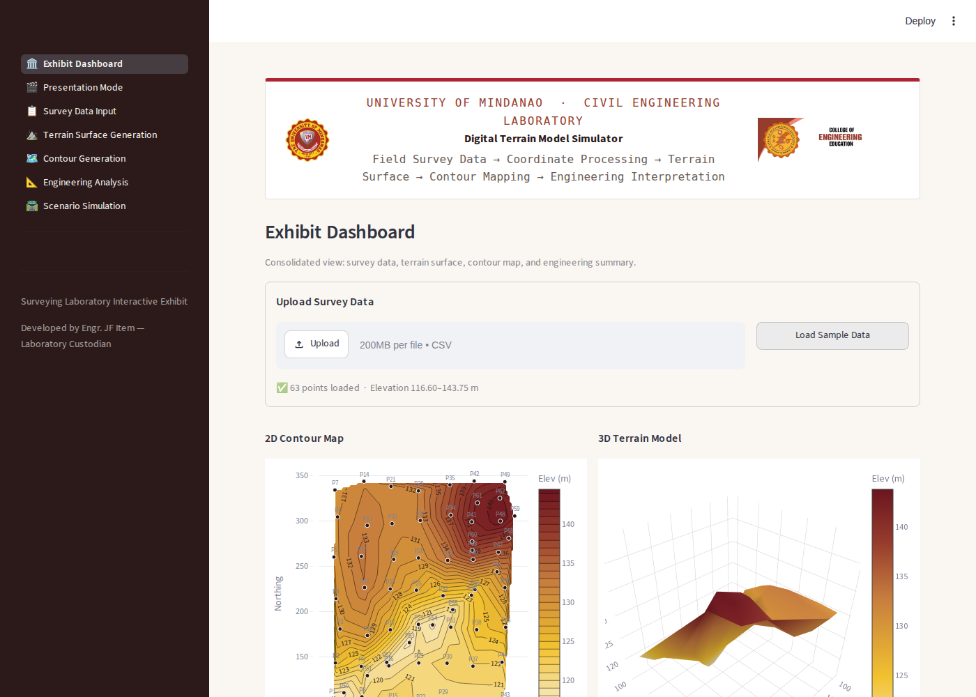
Figure 1 — Exhibit Dashboard with sample data loaded.

3.2 Presentation Mode
A guided, one-click walkthrough for demonstrations. Clicking Start Demonstration loads the sample dataset and steps through four narrated stages — Survey Points, Terrain Surface, Contour Map, and Engineering Decision — using Back, Next, and Restart controls.
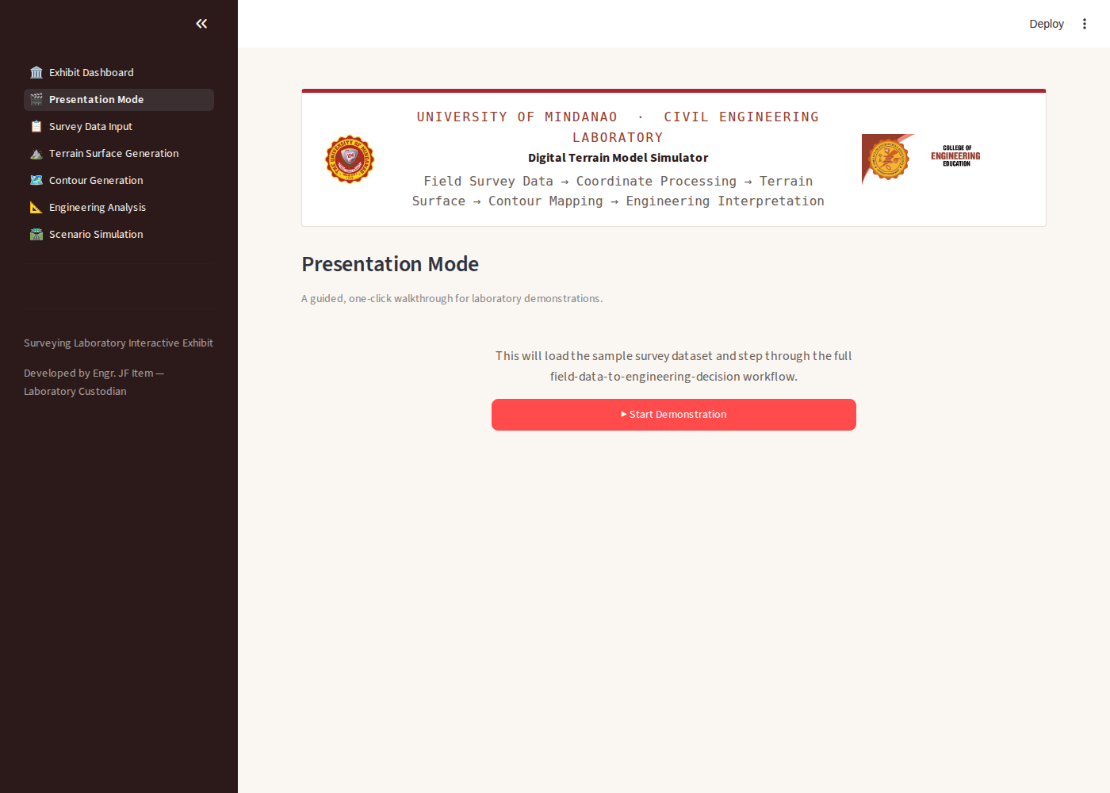
Figure 2 — Presentation Mode start screen.
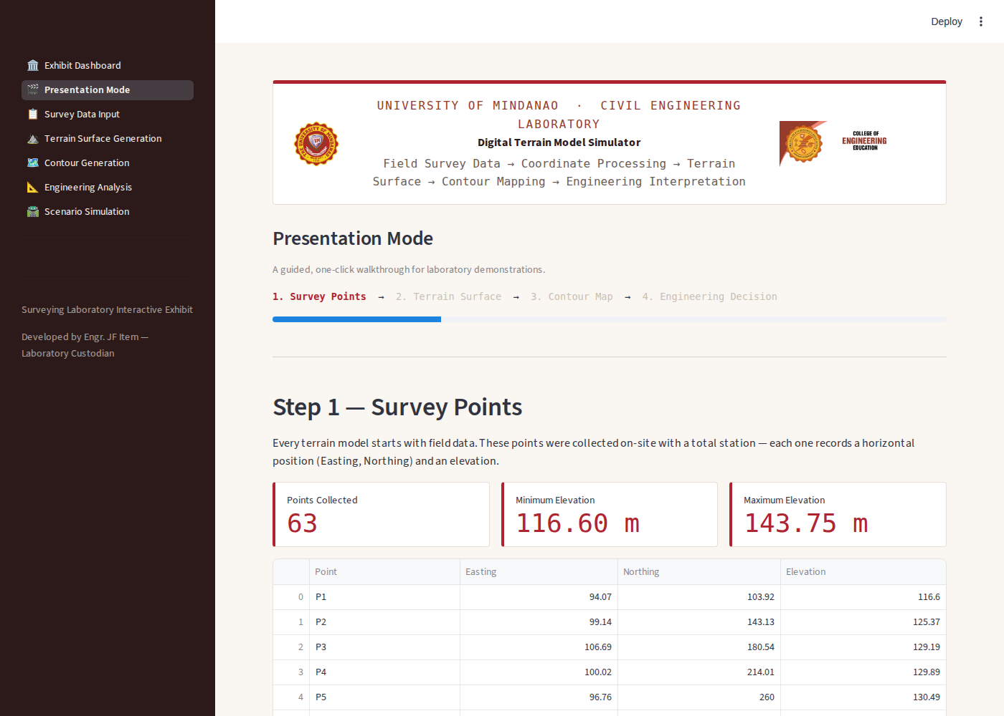
Figure 3 — Presentation Mode, Step 1: Survey Points.

3.3 Survey Data Input
Enter points manually in an editable table, or upload a CSV with columns Point, Easting, Northing, Elevation. The system validates for missing values, duplicate point IDs, and invalid coordinates before accepting the data.
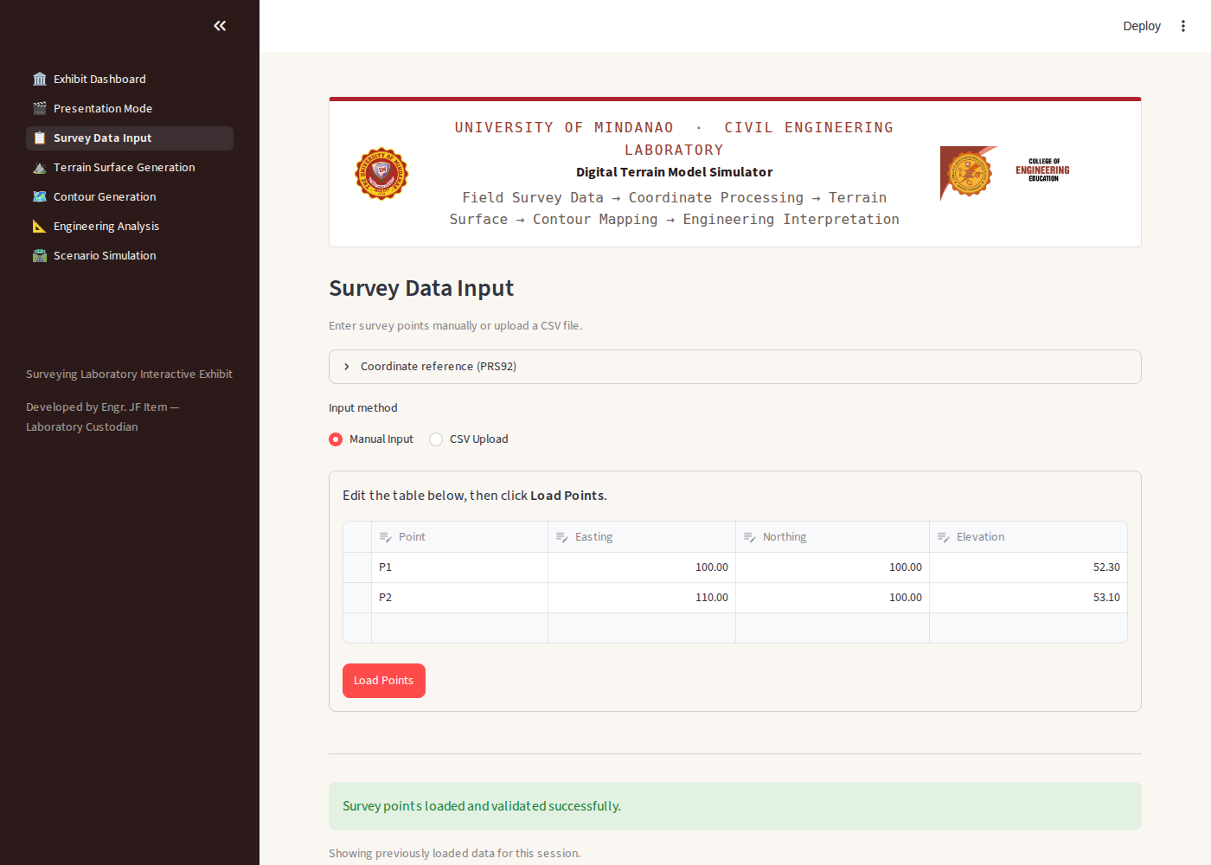
Figure 4 — Survey Data Input page.

3.4 Terrain Surface Generation
Builds the TIN from the loaded points and displays a 2D triangulation view alongside an interactive, rotatable 3D terrain surface.
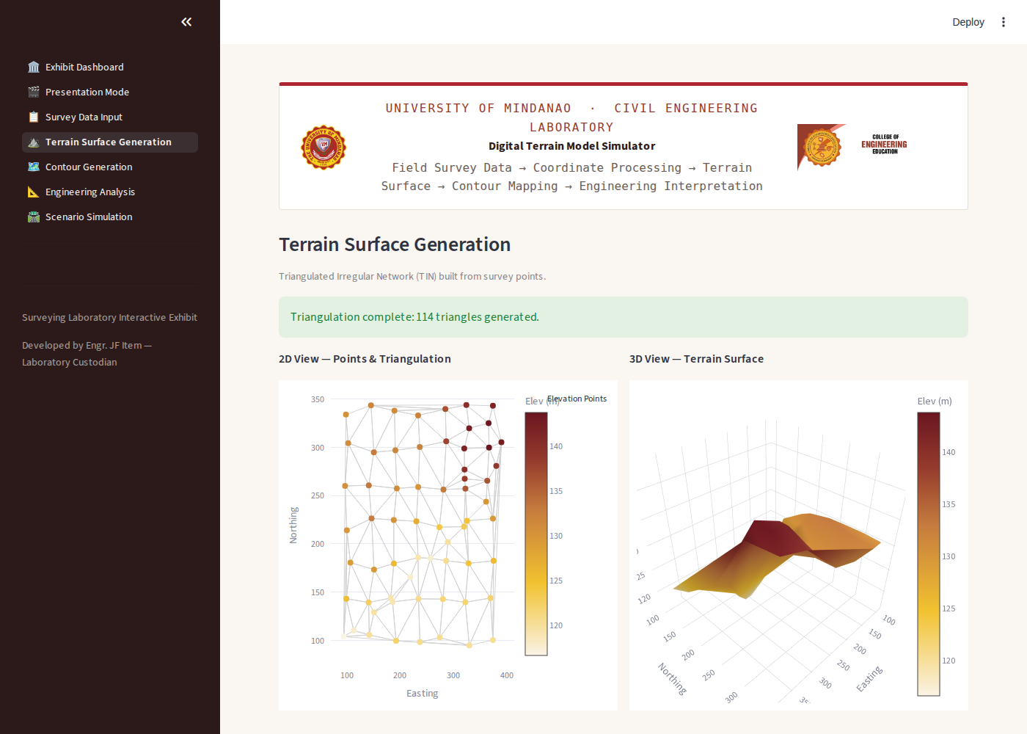
Figure 5 — Terrain Surface Generation page.

3.5 Contour Generation
Generates a filled, labeled contour map at a selectable interval (0.5, 1.0, 2.0, or 5.0 m).
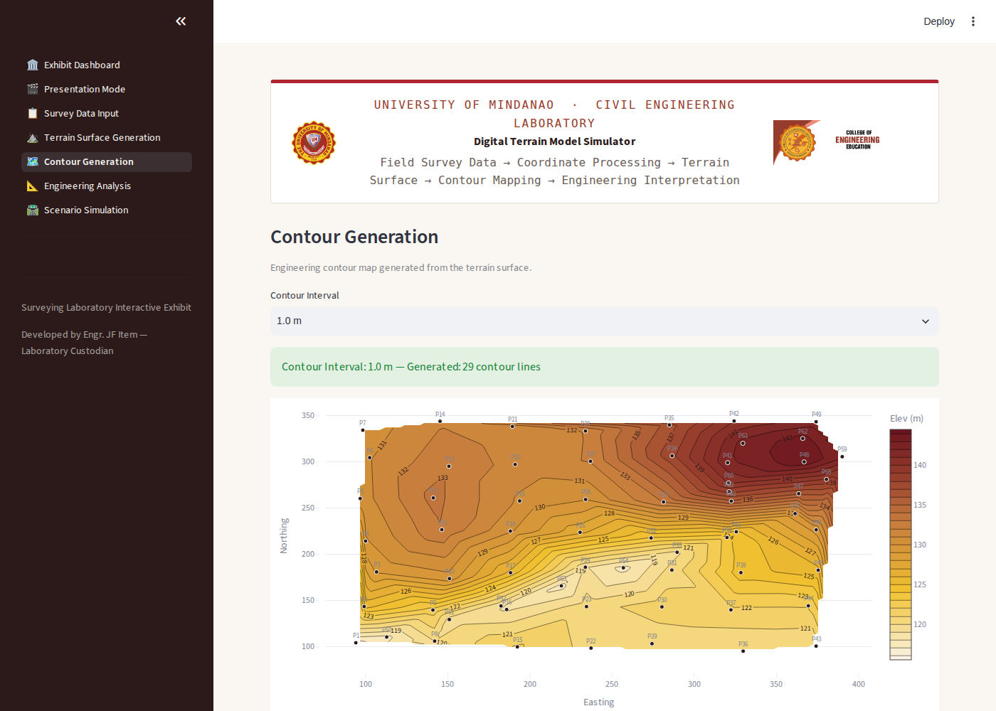
Figure 6 — Contour Generation page.

3.6 Engineering Analysis
Displays elevation statistics, BSWM slope classification, and estimated drainage direction with a visual arrow on the contour map.
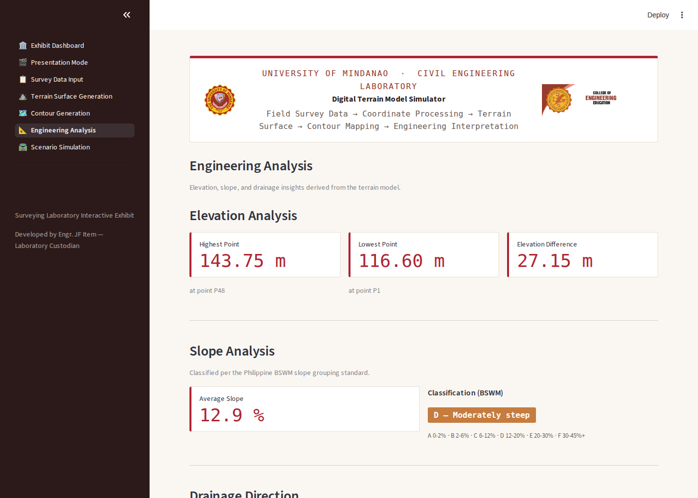
Figure 7 — Engineering Analysis page.

3.7 Scenario Simulation
Lets the user propose a road elevation and see the resulting cut/fill volumes, visualized as a 3D terrain-vs-road-plane view and a 2D cut/fill map.
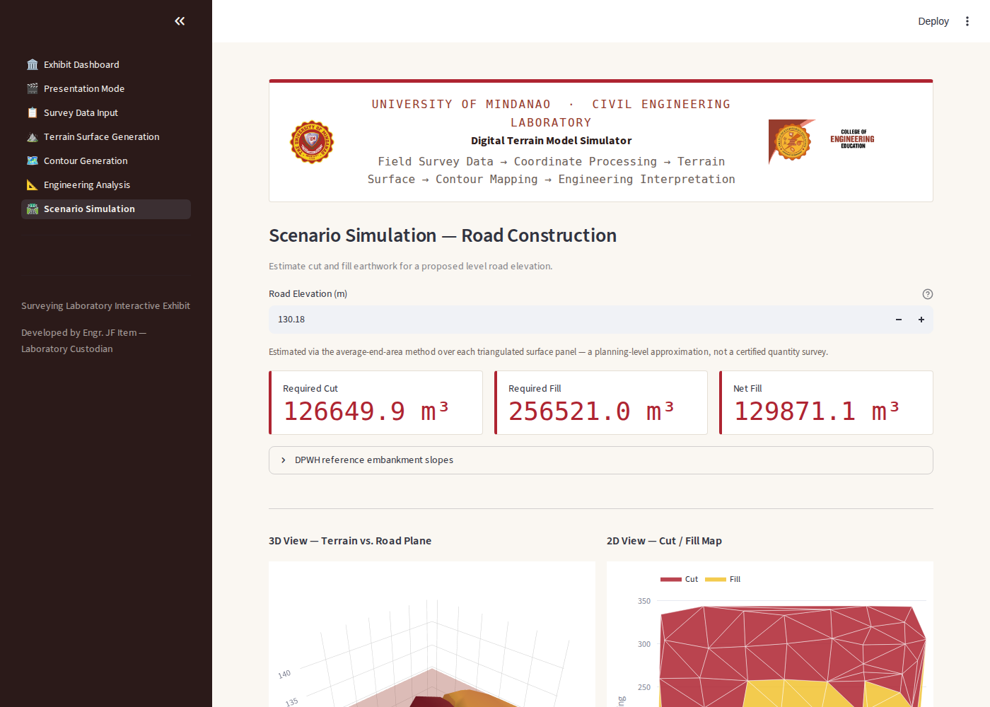
Figure 8 — Scenario Simulation page.

4. Learning Outcomes
After using the DTM Simulator, a student should be able to:
- Explain how discrete survey points are converted into a continuous terrain surface using Delaunay triangulation.
- Interpret a contour map, including how contour spacing relates to slope steepness.
- Classify terrain slope using the Philippine BSWM standard and recognize its significance under Philippine land-use law.
- Estimate drainage direction from elevation data and explain its relevance to site planning.
- Estimate cut and fill earthwork volumes for a proposed road and compare them against DPWH reference embankment standards.
- Connect the full field-survey-to-engineering-decision workflow used in real civil engineering practice.

Surveying Laboratory · University of Mindanao
Developed by Engr. JF Item — Laboratory Custodian

